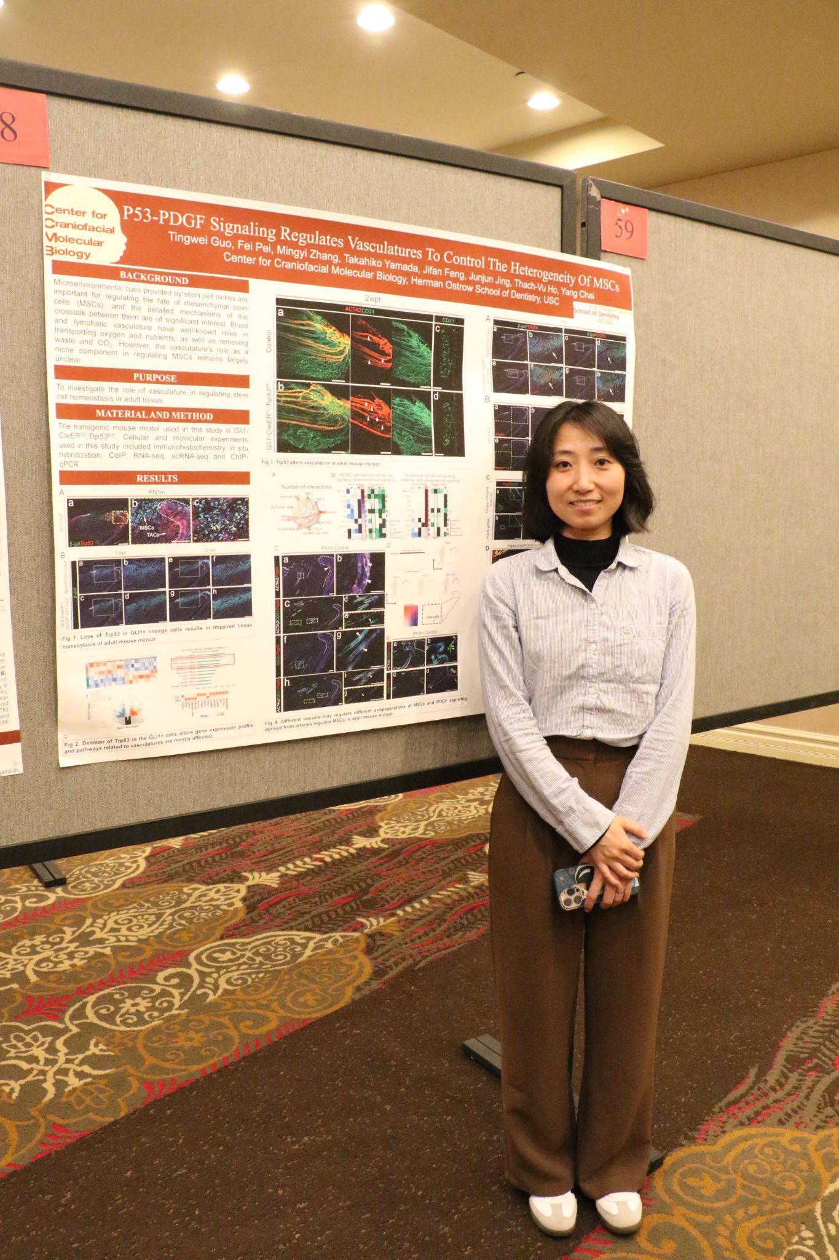

**Trp53 Coordinates with Hippo Signaling During Tooth Root Development**

Tingwei Guo, Fei Pei, Mingyi Zhang, Jifan Feng, Thach-Vu Ho, and Yang Chai

*Center for Craniofacial Molecular Biology, Ostrow School of Dentistry University of Southern California, Los Angeles, CA 90033, USA*

**Background:** Cranial neural crest cells (CNCCs) play an essential role in craniofacial development and function. These cells have the ability to differentiate into multiple cell types, contributing to diverse craniofacial structures, including bones, cartilage, and connective tissue. Despite their significance, the mechanisms governing the cell fate decisions of post-migratory CNCCs remain largely unknown. Transcription factors play a central role in orchestrating these developmental processes by regulating gene expression programs. P53 is a well-known master regulator, extensively studied in cancer biology for its role in controlling cell growth and apoptosis. However, its role in postnatal development, particularly in craniofacial development, is less understood. **Methods:** The transgenic mouse model used in this study was *Gli1-CreER;Trp53fl/fl*. Techniques used in this study included immunohistochemistry, RNAscope, CUT&RUN-seq, bioinformatic analyses, and cell culture. **Results:** In this study, we used the mouse molar as a model to investigate the role of P53 signaling in tooth development, revealing that P53 not only regulates key processes in tooth development but also interacts with the transcription factor Arnt to modulate Hippo signaling. This coordination influences the expression of *Gli1* during the postnatal development of CNCCs. We demonstrated that the interplay among the P53, Hippo, and hedgehog signaling pathways is essential for regulating tooth root development. These insights provide a deeper understanding of how these pathways converge to regulate postnatal craniofacial development. **Conclusions:** These findings suggest that P53 plays a broader role in developmental biology beyond its established functions in cancer, potentially influencing other aspects of postnatal tissue formation and regeneration. **Acknowledgement of research support:** This study was supported by funding from the National Institute of Dental and Craniofacial Research, [National Institutes of Health](https://www.sciencedirect.com/topics/agricultural-and-biological-sciences/national-institutes-of-health) (R01 DE022503, [R01 DE012711](https://www.sciencedirect.com/science/article/pii/S2211124721002783?via%3Dihub#gs2) and U24 DE034163 to Yang Chai).